SH Security Optical Turnstile & Armdrop Turnstile Brochure

Tripod turnstile, Flap barrier, Swing barrier, Full-height turnstile, Half-height turnstile, Optical turnstile, Armdrop turnstile etc


Contact: Ms Fenghui Guo
- Website: www.szshanghe.com.cn
- Tel: +86-755-89955830
- Fax: +86-755-89964737
- Mobile: +86-13714573482
- Address: 3rd Floor, Block C, Wanshifa Industrial Park, 1st Industrial Zone, Bantian Town, Longgang District, Shenzhen, China , 518129
- Email: szshkj@gmail.com
szshkj2010@163.com
- Msn: szshkj@hotmail.com
- Skype: fenghui.guo szshkj
- Yahoo: szshkj@yahoo.com.cn
- G-talk: szshkj@gmail.com

Optical Turnstile Series

SH601 Dimension: 1200*220*1000 mm
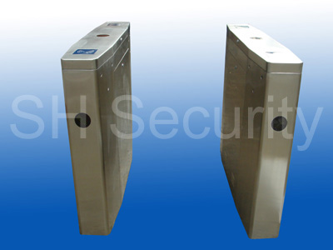

Specifications:
Power Supply | AC110V±10V ，60Hz  AC220V±10V ，50Hz
Power Consumption | 100 watts/24V
Working Temperature | －15℃ ～ 60℃
Related Humility | <=95%
Response Time | 0.5s
Passage Width | 600-700mm
Interface | RS485, communication distance <=1200m
Input Interface | +12V electrical signal or DC impulse signal with width >100ms
Stainless Steel Specification | Cover 1.5mm 304-type  Housing 1.2mm 304-type
Working Interface | ID, IC, Magnetic, Barcode cards
Net Weight | 40Kgs
Package Material | Wooden Box
Package Weight | 60Kgs
Package Dimension | 1280*280*1080mm

Armdrop Turnstile Series
SH701 Dimension: 600*220*1000 mm
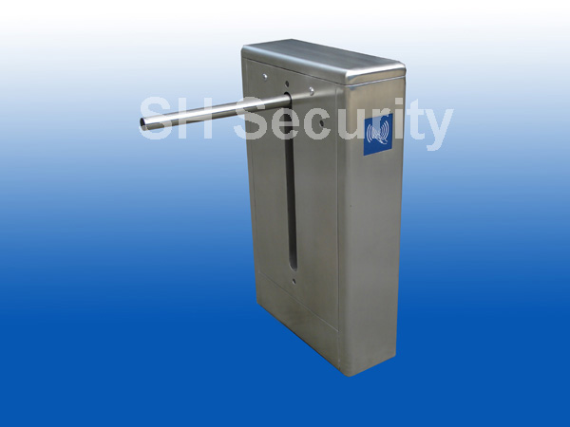

Specifications:
Power Supply | AC110V±10V ，60Hz  AC220V±10V ，50Hz
Power Consumption | 100 watts/24V
Working Temperature | －15℃ ～ 60℃
Related Humility | <=95%
Response Time | 0.5s
Passage Width | 600mm
Arm Length | <=500mm (length outside housing)
Interface | RS485, communication distance <=1200m
Input Interface | +12V electrical signal or DC impulse signal with width >100ms
Stainless Steel Specification | Cover 1.5mm 304-type  Housing 1.2mm 304-type
Working Interface | ID, IC, Magnetic, Barcode cards
Net Weight | 40Kgs
Package Material | Wooden Box
Package Weight | 60Kgs
Package Dimension | 680*300*1080mm

Contact: Ms Pepsi Wang
- Website: www.szshanghe.com.cn
- Tel: 0086-755-89955830
- Fax: 0086-755-89964737
- Mobile: 0086-13428936482
- Address: 3rd Floor, Block C, Wanshifa Industrial Park, 1st Industrial Zone, Bantian Town, Longgang District, Shenzhen, China , 518129
- Email: pepsi.wang@gmail.com
peipeichocolate@163.com
- Msn: pepsi.wang@hotmail.com
- Skype: peipeichocolate
- Yahoo: superpepsi2009@yahoo.com
- G-talk: pepsi.wang@gmail.com

